Name _______________________________________________ ES Unit 7 Sheet: Severe Storms & Climate

Students will answer all vocabulary, study guide questions and additional study problems as outlined below. Supplemental and Reading Material provide additional information to help master concepts.

Essential Standards: | Students Will Be Able To:
2.5.4 Predict the weather using maps  and data.  2.5.5 Explain how human activities  affect air quality.  2.6.1 Differentiate between weather  and climate.  2.6.2 Explain changes in global climate  due to natural processes.  2.6.3 Analyze the impacts humans  have had on global climate  change.  2.6.4 Attribute changes to Earth’s  systems to global climate change. | - Explain major climate categories in the Koppen climate system.  - Summarize natural processes that can and have impacted climate change.  - Explain the process of greenhouse effect including greenhouse gasses.  - Describe seasonal changes due to the tilt and revolution of the Earth.  - Discuss how other human activities impact the quality of our atmosphere.  - Discuss ways to mitigate effects of human activities on the atmosphere.  - Analyze how changes in global temperatures affect the biosphere.  - Observe, analyze and predict weather using, maps, data, and technological resources  - Interpret and analyze weather maps and humidity charts  - Explain how acid rain is formed and how humans can affect the pH of rain.

Vocabulary—Define, know, and be able to apply the following terms:

- Thunderstorm
- Tornado
- Hurricane
- Eye (of hurricane)
- Storm Surge
- Monsoon
- Land Breeze
- Sea Breeze
- Barometer
- Climate
- Koppen Climate System
- Greenhouse Effect
- Global Warming
- El Niño
- La Niña
- Climate Change
- Greenhouse Gas
- Acid Deposition
- Air Quality Index (AQI)
- Ground Level Ozone

Academic students complete vocabulary with asterisks *only. Honors students complete all 20 words.

Study Guide—Answer, know, and understand the following concepts:
- Explain how each of these factors affect climate: elevation, distance to water, latitude, vegetation, topography, global wind currents, and global water currents.
- Sketch a diagram illustrating the tropical, temperate, and polar latitudes.
- Explain the importance of the greenhouse gas layer, identifying the gases it includes.
- Explain the difference between the greenhouse effect and enhanced greenhouse effect.
- Describe both natural and man-made causes of climate change.
- Discuss the impacts of El Nino and La Nina on weather and climate.
- Describe the major categories in the Koppen Climate System.
- Explain how changes in global climate affect agriculture, species diversity, and ecosystem balance.
- Identify natural and/or human factors of acid deposition (acid rain).
- Discuss the impact of acid deposition on the four spheres of earth.
- Identify what each of the following weather instruments measure: thermometer, barometer, hygrometer, anemometer, and rain gauge.

Supplemental--Do practice the following activities as you work through the unit:
- Draw diagrams to illustrate the layers of the atmosphere, air mass interactions, and energy transfer.
- Read a Koppen Climate map and identify characteristics of individual climates.

Unit Reading Material:

- Textbook: Chapter 17-21
- Digital Textbook: Ch. 7.21-7.43
- Class Notes
- Handouts

Additional Study Problems:
- Identify this type of frontal system and explain why it causes severe storms to form.

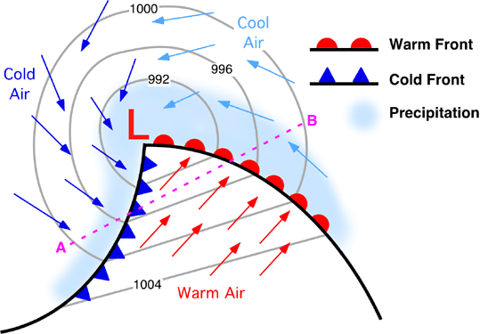

- Draw a land breeze and sea breeze. Explain movement of winds for both and identify why they occur.

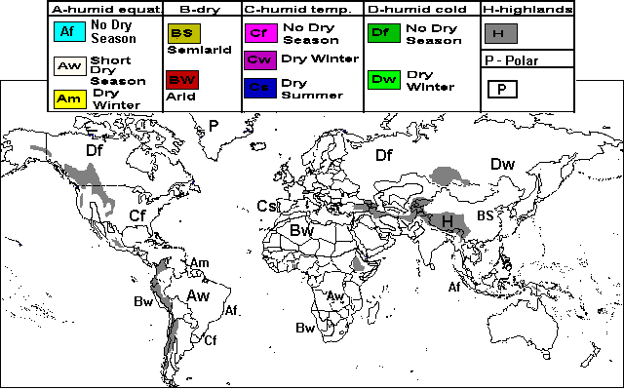
- Color in each climate area: (Choose your own colors to correspond to each area)
- Explain what factors would cause the differences in air quality between July and October for Sacramento, CA:
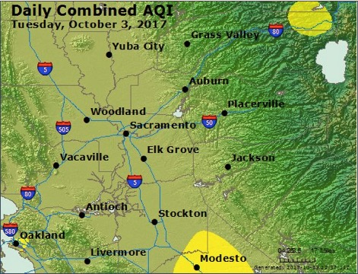
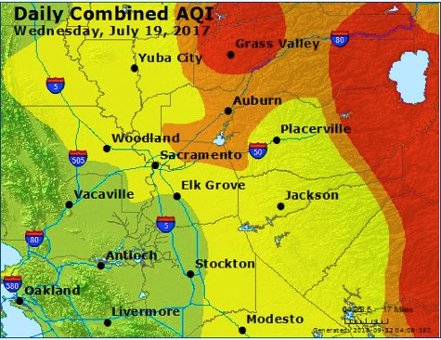
July: average AQI unhealthy (red) October: average AQI good (green)

- Explain how El Niño and La Niña occur and what changes in weather are expected with each.
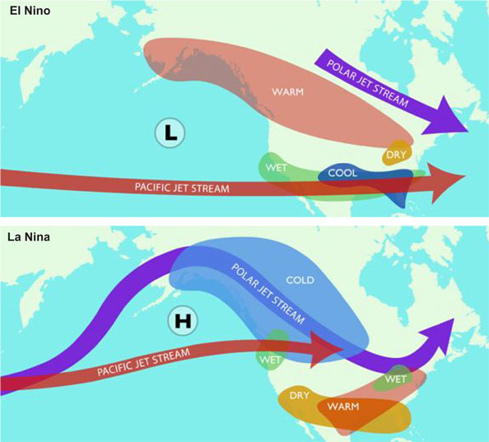

- Complete the table related to acid deposition:
Pollutant | Reaction that occurs to produce acid rain: | Source(s) of pollutant | How it affects the environment & humans
Nitrogen oxide
Sulfur dioxide

